If you have a weak immune system and would like to inform others, please feel free to print this out and stick it in your window.
----------------------------------------------------------------------------------------------------------
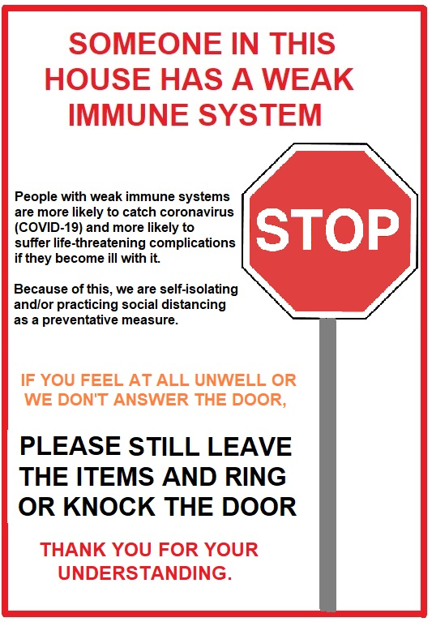

Steff. Webmaster Canterbury Branch RAA. 20-03-2020.

